**Video Analysis: Activity 2**

In this activity you will explore the motion graphs of a mass oscillating on a spring. The motion done by the mass is called simple harmonic motion and it is very important in physics. You are going to need the software Tracker (<https://physlets.org/tracker/>) and the video of the motion (shm_200.mp4 and shm_unkn1.mp4 available on Managebac) .

1. ~~Import the video into tracker.~~ **~~Start with shm_200.mp4~~**~~) .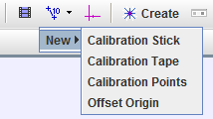~~
2. ~~Calibrate the video using a Calibration Stick. Set the stick to be the length given at the beginning of the video. If you don’t know what calibration is find out (you can ask your teacher).~~
3. ~~Use the black arrows in the sliding bar to select the beginning of the motion we will analyze.~~
4. ~~Show the coordinate system (button next to calibration stick) and place it approximately between the highest and lowest point the mass reaches.~~
5. ~~Create Point mass~~
6. ~~Go to the first frame where the letters are gone~~
7. ~~Ctrl+Shift+click on a point of the mass that is characteristic (easy to recognize)~~
8. ~~Make the search area (dotted square around object) large enough so that the ball will be within that square in the next frame.~~
9. ~~Click search. This will search in all of the frames in the video. If it does not find it, it will stop. That is probably due to the selection of a point in step 8 that is not characteristic enough for the software. Go to delete->delete all and repeat from step 8.~~
10. ~~Observe the graph on the right.~~
11. ~~Select the axis you want to plot~~
12. ~~Double click to analyze (for example fit a line of best fit)~~

Now you should be ready to complete the task and answer the questions on the next page.

**Tasks and Questions**

1. Are interested in the x or y motion of the mass? Select the appropriate one and paste the graph here. What kind of graph is it? Have you studied in math any mathematical function that looks like the graph you are obtaining?

y motion

a sinusoidal shaped graph

y = Asin($ωx+φ)$

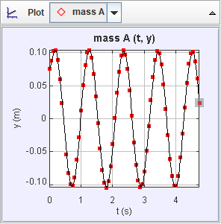

1. Double click on the graph (it will open a new window). Use the analyze functions to add a curve fit with the mathematical function that you consider will fit best.

Can you guess what the physical meaning of the coefficients are?

A: _______ 0.1035_____ Physical meaning: amplitude

B:________5.788_______ Physical meaning: frequency 2 $π$/T, related to the period

C:________0.6156______ Physical meaning: initial phase the phase of motion initially

1. The Period of an oscillation is the time it takes to complete a full cycle (return to the same point with the speed in the same direction).
   1. From the graph determine the Period of oscillation in seconds.

(From graph) T= 1.089s

* 1. From the video by moving frames and considering the time between each frame is 66.67ms.

(From video and frames) T=1.067s

* 1. Are they the same? What is the difficulty in this measurement?

No, because different periods are chosen to measure the period, and there is slight difference between each.

To determine the period of one oscillation, it is better to find two points with the maximum or minimum height, find the difference between these two points, and divided by the number of periods. The reason for doing so is that at those points, the mass has the velocity almost equals zero. However, it is still hard to find two points when the mass has exactly zero velocity.

* 1. Considering that the coefficient B is equal to 2π/T, find the value of T from the coefficient B you found in question 2.

(From coefficient) T= 1.086

* 1. From these three values of T provide a final answer of T with an estimated uncertainty

T= ___1.08___±____0.01____s

1. Knowing that the period of oscillation T relates to the hanging mass and the spring constant of the spring through this equation

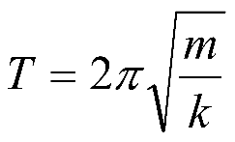 Find the value of the spring constant with uncertainty and units (assume the uncertainty of the mass is so small that it can be ignored):

k=____6.8____±__0.1___

1. Get the graph for the vertical velocity of the mass vs time. Paste it here and describe the similarities and differences compared to the y-position vs time graph. (you can see them both simultaneously if you click on plot and select 2)

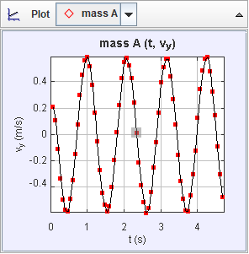

Similarities:

* they are both sinusoidal shaped plots
* their period is the same

Differences:

* the amplitude is different, the velocity one is larger.
* when the graph of y motion takes extreme values, the vertical velocity is zero.

1. According to your observations of the graphs, should the coefficient B multiplying the time in curve of best fit A*Sin(Bt+C) be the same? Make a prediction and then go to analyze and try it out.
2. Calculate the ratio between the A coefficient of the velocity vs time graph and the A coefficient of the position-time graph in question number 2. What do you find?

$$\frac{A_{2}}{A_{1}}=\frac{0.5817}{0.1035}=5.620$$

It is approximately

1. Get the graph for the vertical component of the acceleration vs time. Paste it here and describe the similarities and differences compared to the previous two graphs.

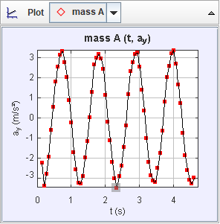

Similarities:

* they are all sinusoidal shaped plots
* their periods are all the same
* the x intersect of acceleration vs time graph is the same as the displacement vs time one.

Differences:

* the amplitudes are different, the amplitude of the graph of acceleration vs time is greatest.
* when the graph of y motion takes extreme values, both the vertical acceleration and the vertical velocity are zero.

1. According to your observations of the graphs should the coefficient B multiplying the time in curve of best fit A*Sin(Bt+C) be the same as before? Make a prediction and then go to analyze and try it out.
2. Calculate the ratio between the A coefficient of the acceleration vs time graph and the A coefficient of the velocity-time graph. What do you find? Is it similar to the ratio in question 7? Is it a coincidence (check the units)?

$$\frac{A_{3}}{A_{2}}=\frac{3.251}{0.5817}=5.589$$

Almost the same

1. Plot a graph of vertical acceleration vs vertical position and paste it here. Describe and explain the graph. Is this graph in agreement with Hooke’s law? Explain why. From the graph go to analyze, then plot a best fit line and from the coefficients and the mass determine the spring constant k.

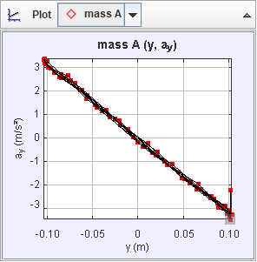

According to the graph, there is approximately an inverse relationship between the vertical acceleration and position, meaning:

$$\frac{a}{x}=\frac{F}{m⋅x}=c$$

$$\frac{F}{d}=-mc$$

In which a is vertical acceleration, d is the displacement, and c is a constant.

And according to Hooke’s law,

$$F=k_{Δ}x$$

$$\frac{F}{Δx}=k$$

Which also means that the force applied divided by the displacement is a constant k.

Thus, k = mc, and the graph is in agreement with Hooke’s law.

By plotting the line of best fit, we get that the gradient is -31.47, meaning c = -31.47. Thus, we get:

$$k=-m⋅c=31.47*0.2=6.294$$